TERMS OF REFERENCE
SUPPLY, DELIVERY, INSTALLATION, TESTING AND COMMISSIONING OF CLOSED CIRCUIT TELEVISION (CCTV) AT PPA HEAD OFFICE

- BACKGROUND

The Philippine Ports Authority Head Office intends to upgrade its existing video surveillance system that includes a command and control style operator console, a high video management software system, and high resolution IP based camera and a fiber optic backbone.

- OBJECTIVES

- To provide PPA Head Office a video surveillance system that shall have a platform solution optimized for applications to view, store and manage real time and recorded video in a networked environment.
- To provide a video surveillance system that has highly scalable and reliable platform to enable customized network based surveillance applications.
- To provide a fiber optic backbone for the video surveillance network infrastructure that would provide IP connectivity for cameras and Monitoring Stations.

- SCOPE OF WORKS

            - Supply, Delivery, Installation, Testing and Commissioning of Brand new Closed Circuit Television (CCTV) to include:
*installation Multi-mode Fiber Optic Cable
*Installation of Category 6 cable
*Installation of Indoor/Outdoor Cameras
*Installation of Fully Managed Power over Ethernet (POE) Switch

            - Conduct Training of CCTV Operators

- TECHNICAL SPECIFICATIONS

Indoor/Outdoor Camera Technical Specifications
Item | Specification
Image sensor | 1/2.5" CMOS, 5 megapixel, progressive scan  L12 (180°x160°), L25 (82°x61°)
Lens options | 12 to 160mm format horizontal angle 180°C to 13°C
Max Frame rate (MxPEG) | HD (1280x720): 30 fps, MEGA: 30 fps, QXGA: 20 fps, 6MEGA: 8 fps
DVR recording | MicroSD Slot (recording inside the camera), up to 64GB; 4-GB card preinstalled
External Storage | Directly on NAS and PC/Server without additional recording software
Operating condition | IP66, - 30°C to +60°C (-22"F to +140"F)
Image Processing | Backlight compression, automatic while balance, image distortion correction, panorama image, motion detection, Sensor
Virtual PTZ | Digital Pan/Tilt/Zoom, continuous 8x zoom
Alarm/Events | Video Motion, external signals, temperature sensor, PIR, microphone, shock detector, notification via eMail, FTP, telephony (VoIP, SIP), visual/acoustic alarm, pre- and post-alarm images
Flexible event logic: | Yes
Sensor resolution | Color: 2592x1944 pixels Black & White: 2592x1944 pixels
Compression | MxPEG, M-JPEG, JPEG, H.264 (SIP Video Only)
Min. light sensitivity: | Color: 0.25 lux (t=1/60s) • 0.013 lux (t=1/1s)  B/W: 0.05 lux (t=1/60s) • 0.0025 lux (t=1/1s)
Audio | Integrated microphone and Speaker (Voip) lip-synchronous audio, intercom, sound recording
Internal Sensors | Temperature, PIR, microphone illumination, shock detector
Interfaces | Ethernet 10/100, MiniUSB, MxBus
Security | User-/Group management, HTTPS/SSL, IP address filter, IEEE 802.1x, Intrusion Detection
Certificates | EMV (living environments, industry), CE, FCC, 2011/65EU, 2004/108/EG, UL 60950, CSA C22.2, EN 55022:2010, EN 55024:2010, DIN EN 61000-6-1:2007, DIN EN 61000-6-2005, CISPR 22:2008 mob., EN 50121-4:2007, CFR 47, FCC Part 15B, Ctick AS/NZS 3548
Power Supply | PoE+ IEEE 802.3at 4to5W max IEEE 802.3at, variable PoE class, typ. 4.5 W
Software (free of charge) | Video Management System, (MXCC, MXMC and IOS app) free of charge
Others | Intelligent Motion Detection, Number Plate recognition, Lowlight exposure optimization, Fail over storage, Simultaneous Recording, Event Search & Live Viewing, High-Resolution Digital Image Rather Than TV Quality, Decentralized Concept, No Storage Limit, Unlimited scalability.
Outdoor: | Outdoor, weatherproof (IP66), -30...+60 °C
Sensor modules: | L12 - L160, horizontal angle 180° to 13°
Max. image size: | with 2 sensor modules: 4096 x 1536 (6.2 MEGA)
Zoom/Pan: | Continuous up to 8x Zoom + Pan/Tilt (digital)
Max. frame rate: | 30 fps (MEGA)
Min. light sensitivity: | Color: 0.25 lux (t=1/60s) • 0.013 lux (t=1/1s)  B/W: 0.05 lux (t=1/60s) • 0.0025 lux (t=1/1s)
Interfaces: | Ethernet 10/100 Mbit, MiniUSB, MxBus,  In/Out and RS232 with accessories
Internal DVR: | Up to 128 GB with MicroSD card
Audio functions | Microphone and speaker integrated,  lip-synchronous audio, two-way speaker, audio recording
Power supply: | PoE (IEEE 802.3af/t) • PoE-Klasse variable • typ. 5.0 W
Software | Video-Management-Software(included), Control room software (included)
Alarm/Ereignisse: | VideoMotion, external signals, temperature sensor, PIR, microphone, shock detector, notification via eMail, FTP, telephony (VoIP, SIP), visual/acoustic alarm, pre- and post-alarm images
Flexible event logic: | yes
External storage: | Up to 4 TB on PC/Server/NAS
Warranty | Three (3) Year Service and Product

Fully Managed Power over Ethernet (POE) Switch Technical Specifications
Item | Specification
Ports | 24 RJ-45 autosensing 10/100/1000 ports (IEEE 802.3 Type 10BASE-T, IEEE 802.3u  Type 100BASE-TX, IEEE 802.3ab Type 1000BASE-T);  Duplex: 10BASE-T/100BASE-TX: half or full; 1000BASE-T: full only  4 fixed Gigabit Ethernet SFP ports  1 Dual-personality (RJ-45 or USB micro-B) serial console port
Traffic prioritization (IEEE 802.1p) | allows real-time traffic classification with support for eight priority levels mapped to either two or four queues; uses weighted deficit round robin (WDRR) or strict priority (SP)
Port-based: | prioritize traffic by specifying a port and priority level
VLAN-based | prioritize traffic by specifying a VLAN and priority level
Class of Service (CoS) | sets the IEEE 802.1p priority tag based on IP address, IP Type ofService (ToS), Layer 3 protocol, TCP/UDP port number, source port, and DiffServ
Rate limiting | sets per-port ingress enforced maximums for all ingressed traffic, or for broadcast, multicast, or unknown destination traffic
Layer 4 prioritization | enables prioritization based on TCP/UDP port numbers
Flow control | helps deliver reliable communication during full-duplex operation
Web graphical user interface (GUI) | HTML-based easy-to-use graphical interface allows configuration of the switch from any Web browser
Command-line (CLI) | robust command-line interface provides advanced configuration and diagnostics
Simple Network Management Protocol (SNMPv1/v2c/v3) | allows a switch to be managed with a variety of third-party network management applications
Virtual stacking | single IP address management of up to 16 switches
sFlow (RFC 3176) | wire-speed traffic accounting and monitoring configured by SNMP  and CLI with three terminal encrypted receivers
IEEE 802.1AB Link Layer Discovery Protocol (LLDP) | automates device discovery protocol for easy mapping by network management applications
Logging | provides local and remote logging of events via SNMP (v2c and v3) and syslog; provides log throttling and log filtering to reduce the  number of log events generated
Port mirroring | allows traffic to be mirrored on any port or a network analyzer to assist with diagnostics or detecting network attacks
• RMON (remote monitoring) | provides advanced monitoring and reporting capabilities for statistics, history, alarms, and events
Find-Fix-and-Inform | finds and fixes common network problems automatically, then informs the administrator
Friendly port names | allow assignment of descriptive names to ports
Dual flash images | provide independent primary and secondary operating system files for backup while upgrading
Multiple configuration files | allow multiple configuration files to be stored to a flash image
Locator LED | allows users to set the locator LED on a specific switch to either turn on, blink, or turn off; simplifies troubleshooting by making it easy to locate a particular switch within a rack of similar switches
Per-port LEDs | provides an at-a-glance view of status, activity, speed, and full-duplex operation
Power and fault LEDs | display any issues
IPv6 host | allows the switch to be deployed and managed at the edge of an IPv6 network
Dual stack (IPv4/IPv6) | supports connectivity for both protocols; provides a transition mechanism from IPv4 to IPv6
MLD snooping | forwards IPv6 multicast traffic to the appropriate interface; prevents IPv6 multicast traffic from flooding the network
IEEE 802.3af Power over Ethernet (PoE) | provides up to 15.4 W per port to IEEE 802.3af-compliant PoE-powered devices such as IP phones, wireless access points, and security cameras
IEEE 802.3at Power over Ethernet Plus | provides up to 30 W per port to IEEE 802.3 for PoE/PoE+ powered devices such as video IP phones, IEEE 802.11n wireless access points, and advanced pan/tilt/zoom security cameras
Auto-MDIX | adjusts automatically for straight-through or crossover cables on all ports
Pre-standard PoE support | detects and provides power to pre-standard PoE devices
Small form-factor pluggable (SFP) slots | provides fiber connectivity such as Gigabit-SX, -LX, -LH, and -BX  with four SFP slots
Dual-personality (RJ-45 or USB micro-B) serial console port | gives easy access to switch CLI via front switch location of dual-personality RJ-45 or USB micro-B serial console port
VLANs | provide support for 512 VLANs and 4,094 VLAN IDs
Jumbo packet support | supports up to 9220-byte frame size to improve the performance of large data transfers
16K MAC address table | provides access to many Layer 2 devices
GARP VLAN Registration Protocol | allows automatic learning and dynamic assignment of VLANs
Access control lists (ACLs) | accommodates IPv4/IPv6 port and VLAN-based ACLs
Source-port filtering | allows only specified ports to communicate with each other
RADIUS/TACACS+ | eases switch management security administration by using a password authentication server
Secure Sockets Layer (SSL) | encrypts all HTTP traffic, allowing secure access to the browser-based management GUI in the switch
Port security | allows access only to specified MAC addresses, which can be learned or specified by the administrator
MAC address lockout | prevents particular configured MAC addresses from connecting to the network
IEEE 802.1X | is an industry-standard method of user authentication using an IEEE 802.1X supplicant on the client in conjunction with a RADIUS  server
Web-based authentication | is similar to IEEE 802.1X and provides a browser-based environment to authenticate clients that do not support the IEEE 802.1X supplicant
MAC-based authentication | authenticates the client with the RADIUS server based on the client's MAC address
Secure shell (SSHv2; client and server) | encrypts all transmitted data for secure, remote CLI access over IP networks
Secure shell | encrypts all transmitted data for secure remote CLI access over IP networks
STP BPDU port protection | blocks Bridge Protocol Data Units (BPDUs) on ports that do not require BPDUs, preventing forged BPDU attacks
STP Root Guard | protects the root bridge from malicious attacks or configuration mistakes
Secure management access | securely encrypts all access methods (CLI, GUI, or MIB) through SSHv2 and SNMPv3
Custom banner | displays security policy when users log in to the switch
Secure FTP | allows secure file transfer to and from the switch; protects against unwanted file downloads or unauthorized copying of a switch configuration file
Protected ports CLI | offers intuitive CLI to configure the source-port filters feature by allowing specified ports to be isolated from all other ports on the switch; the protected port or ports can communicate only with the uplink or shared resources
Multiple IEEE 802.1X users per port | provides authentication of up to eight IEEE 802.1X users per port; prevents user "piggybacking" on another user's IEEE 802.1X authentication
Concurrent IEEE 802.1X and Web or MAC authentication  schemes per port | switch port will accept any IEEE 802.1X and either Web or MAC authentications
Switch management logon security | helps secure switch CLI logon by optionally requiring either RADIUS or TACACS+ authentication
LLDP-MED (Media Endpoint Discovery) | is a standard extension of LLDP that stores values for parameters such as QoS and VLAN to automatically configure network devices such as IP phone
• IP multicast (data-driven IGMP) | automatically prevents flooding of IP multicast traffic
IEEE 802.1AB Link Layer Discovery Protocol (LLDP) | is an automated device discovery protocol that provides easy mapping of network management applications
PoE and PoE+ allocations | support multiple method (automatic, IEEE 802.3at dynamic, LLDP-MED fine grain, IEEE 802.3af device class, or user specified) to allocate and manage PoE/PoE+ power for more efficient energy saving
Voice VLAN | uses LLDP-MED to automatically configure a VLAN for IP phones
IP multicast (data-driven IGMPv3) | automatically prevents flooding of IP multicast traffic
Trunking | supports up to eight links per trunk to increase bandwidth and create redundant connections; supports L2, L3, and L4 trunk-load-balancing algorithm
IEEE 802.3ad Link Aggregation Protocol (LACP) | eases configuration of trunks through automatic configuration
IEEE 802.1s Multiple Spanning Tree | provides high link availability in multiple VLAN environments by allowing multiple spanning trees; provides legacy support for IEEE 802.1d and IEEE 802.1w
IEEE 802.3az | reduces power consumption during periods of low data activity
Port low power mode | when no link is detected on a port, the port will automatically go into low-power mode to conserve energy
Fans | variable-speed fans help reduce power consumption
Port LEDs | port link and activity LEDs can be turned off to conserve energy
Switch on a chip | provides highly integrated, high-performance switch design with a nonblocking architecture
Rackable | is mountable in a standard 19-inch rack using included hardware
Wall mountable | allows the switch to be mounted to a wall using included hardware
Surface mountable | allows the switch to be mounted above or below a surface (such as a desk or table) with included hardware
Quiet operation | variable-speed fans adjust for the operating environment while lowering noise and energy consumption needs
Warranty | Lifetime warranty (for as long as you own the product with advance replacement)

Multi-Mode Fiber Optic Cable Technical Specifications
Item | Specification
Optical fibers | Silica glass surrounded by acrylate coating
The filling compound | Hygroscopic gel
The buffer tubes | Thermoplastic and the central members are glass-reinforced plastic (GRP)
The strength members | Aramid and/or fiberglass yarns
Water blocking materials | Impregnated with super absorbent polymers
Cable jacket | Black polyethylene
Armor | Plastic-coated steel tape
Cable Type | Armored
Nominal O.D.  mm (in) | 10.7 (0.42)
Nominal Weight  kg/km (lbs/1000ft) | 120 (78)
Rated Tensile Load Install  N (lbf) | 2700 (600)
Rated Tensile Load Long Term | 890 (200)
Minimum Bend Radius Install  mm (in) | 214 (8.4)
Minimum Bend Radius Long Term  mm (in) | 107 (4.2)
Maximum Attenuation | Single-mode(1310nm/1550nm)0.5/0.5dB/km
1000BASE-SX Distance | 2-5000m
1000BASE-LX Distance | 2-5000m
10GBASE-LX4 Distance | 2-10000m
Temperature Ratings Operation | -40°C to +70°C  (-40°F to +160°F)
Temperature Ratings Installation | -20°C to +60°C  (-22°F to +140°F)
Temperature Ratings Storage/Shipping | -40°C to +70°C  (-40°F to +160°F)
Certification | Certified Installers by the Manufacturer
Warranty | 20 Years System warranty

Category 6 Cable Technical Specifications
Item | Specification
Conductors | 24 AWG solid bare copper
Insulation | Polyethylene, 0.037 in nom dia
Jacket | FR PVC,CM
Filler | Polyethylene
Impedance | 100Ω ± 15%, 1 MHz to 250 MHz
Propagation delay | 536 ns/100 m max. @ 250 MHz
Skew | 45 ns/100 m max. @250 MHz
Mutual capacitance | 5.6 nF max/100 m
Conductor resistance | 66.58Ω max/1000 m
Bend radius | The minimum bending radius is 8x outside diameter during installation and 4x the outside diameter after installation ≈ 1"
Operating temperature | 20°C to 60°C
Storage temperature | -20°C to 80°C
Approvals | UL  ETL Certificate  RoHS Compliant
Certification | Certified Installers by the Manufacturer
Warranty | 20 years warranty

- OTHER TERMS AND CONDITIONS

Upon delivery, actual demonstration and familiarization including training of personnel on the features and operation of the equipment shall be conducted by the supplier.

- WARRANTY

Three (3) years for service and product (indoor/otdoor camera)
Lifetime warranty on power Ethernet switch
Twenty (20) year warranty on Fiber Optic Cable and Category 6 Cable

- CONTRACT DURATION

The proposed Re- bidding for the Supply, Delivery, Installation, Testing and Commissioning of Closed Circuit Television (CCTV) at PPA Head Office should be completed and delivered within Fifteen (15) Calendar days from receipt of Notice to Proceed.

- DOCUMENTARY REQUIREMENTS

- Legal Document

- SEC/DTI/CDA Registration Certificate
- Valid Mayor’s Permit
- Tax Clearance Certificate
- PhilGEPS Registration Certification
- Joint Venture Protocol/Agreement (for JV proponents)
- Authority of the Representative to Negotiate (e.g. Secretary Certificate/Affidavit as Sole Proprietor)

B. Financial Document

- 2014 Audited Financial Statement duly received by the BIR
- Computation of the Net Financial Contracting Capacity (NFCC)
- Annual Tax Income Return

- Technical Document

- Technical Proposal Form
- Brochures or Technical Data Sheet
- Statement of on-going contracts (private and government)
- Statement of single/two similar largest contract the aggregate amount is equivalent to ABC

- BUDGET

The Approved Budget for the Contract shall be TWELVE MILLION PESOS (Php 12,000,000.00)

Annex “A”

Floor Plan

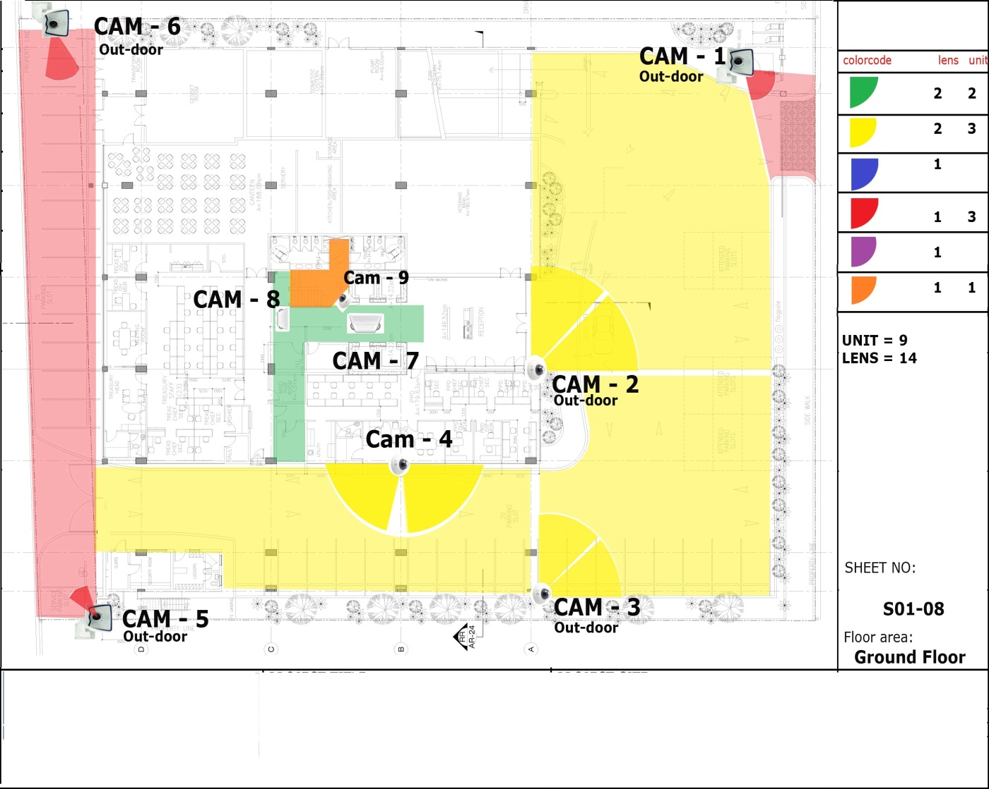
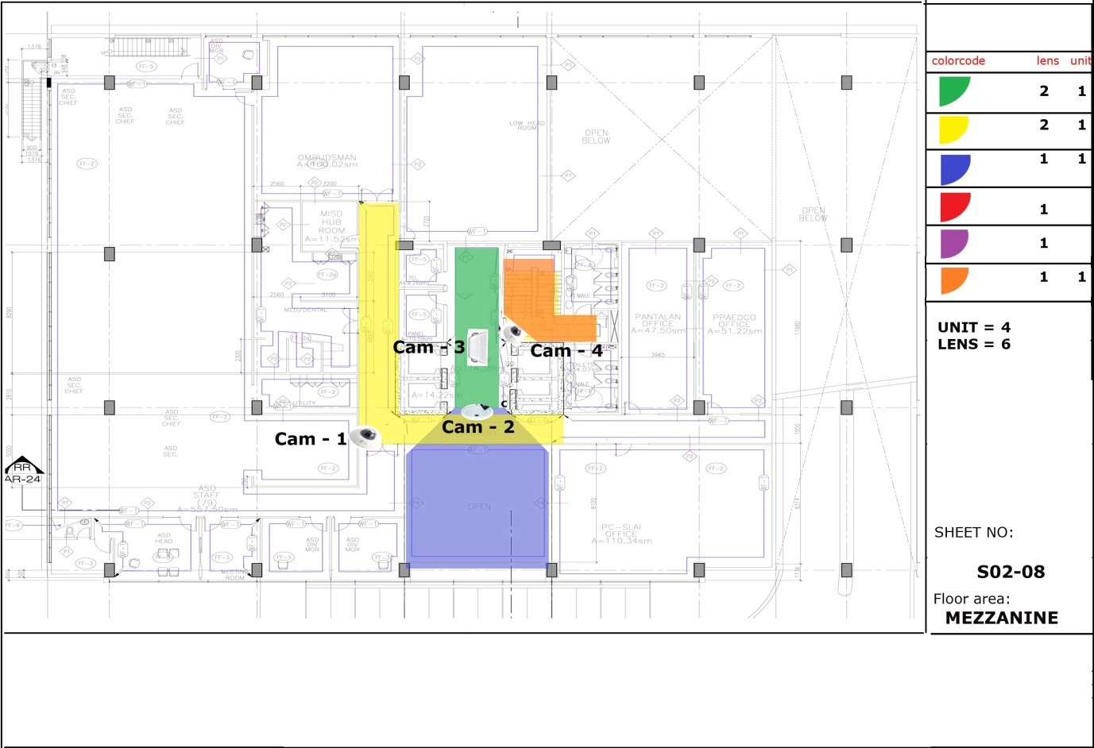

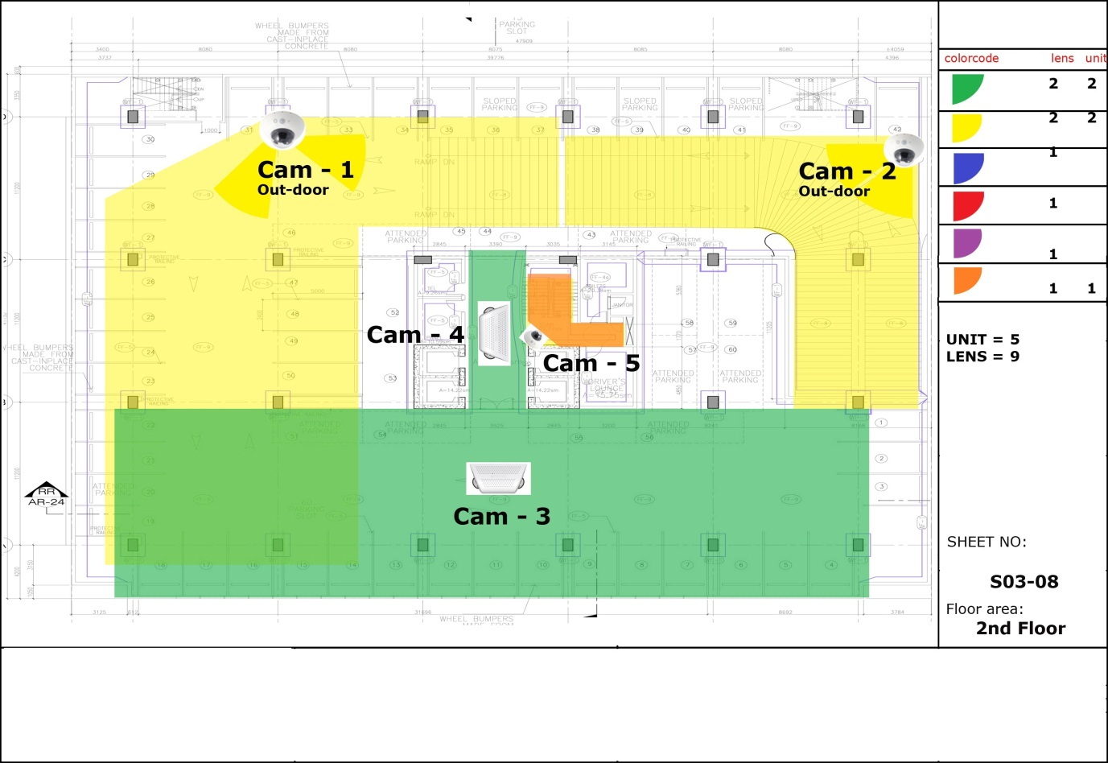

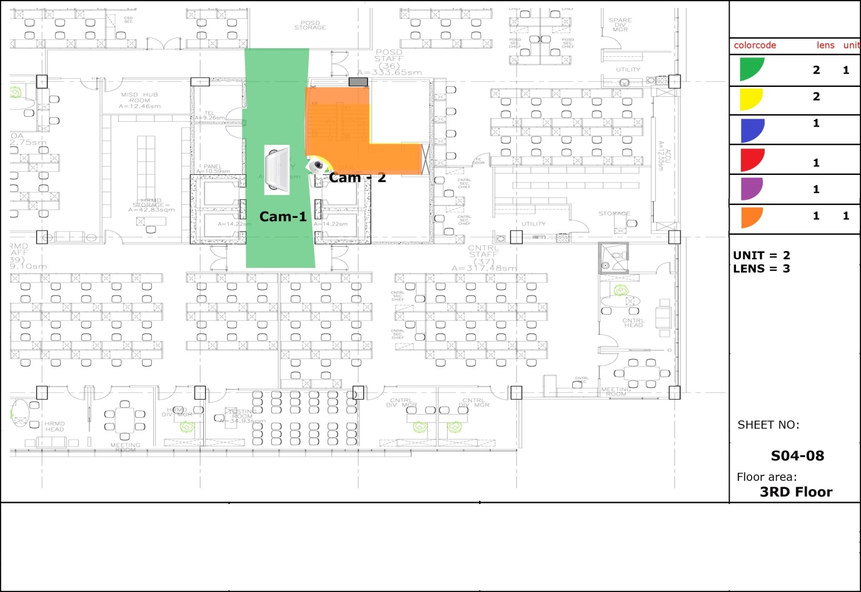

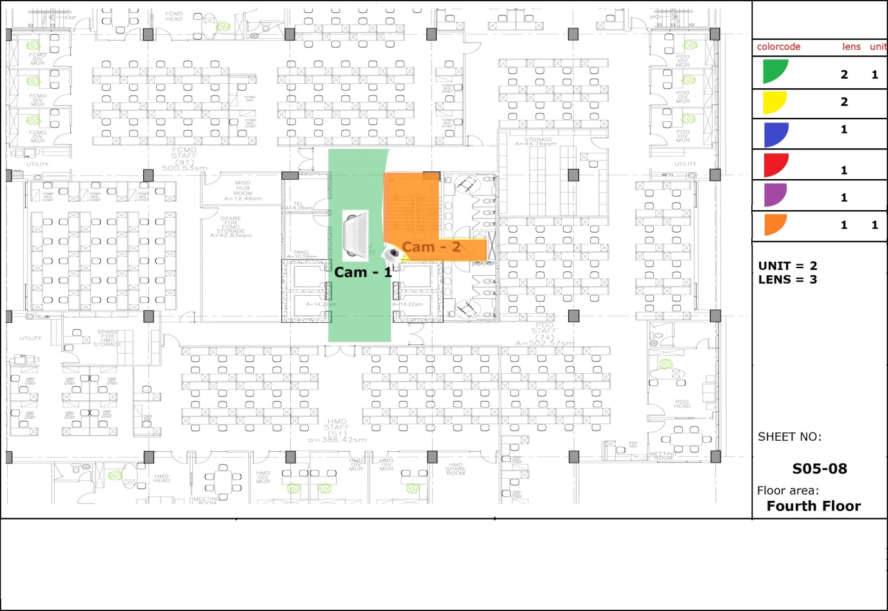

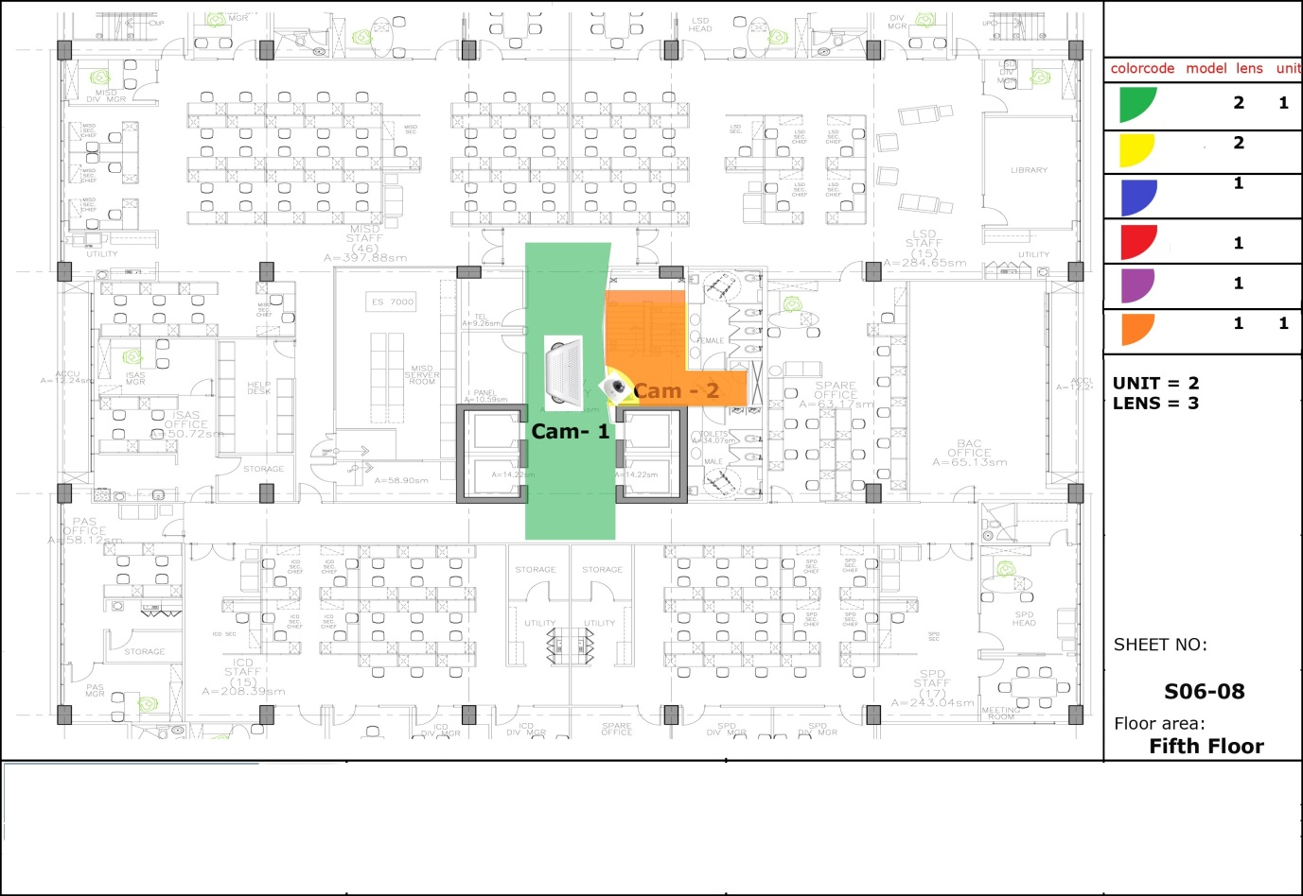

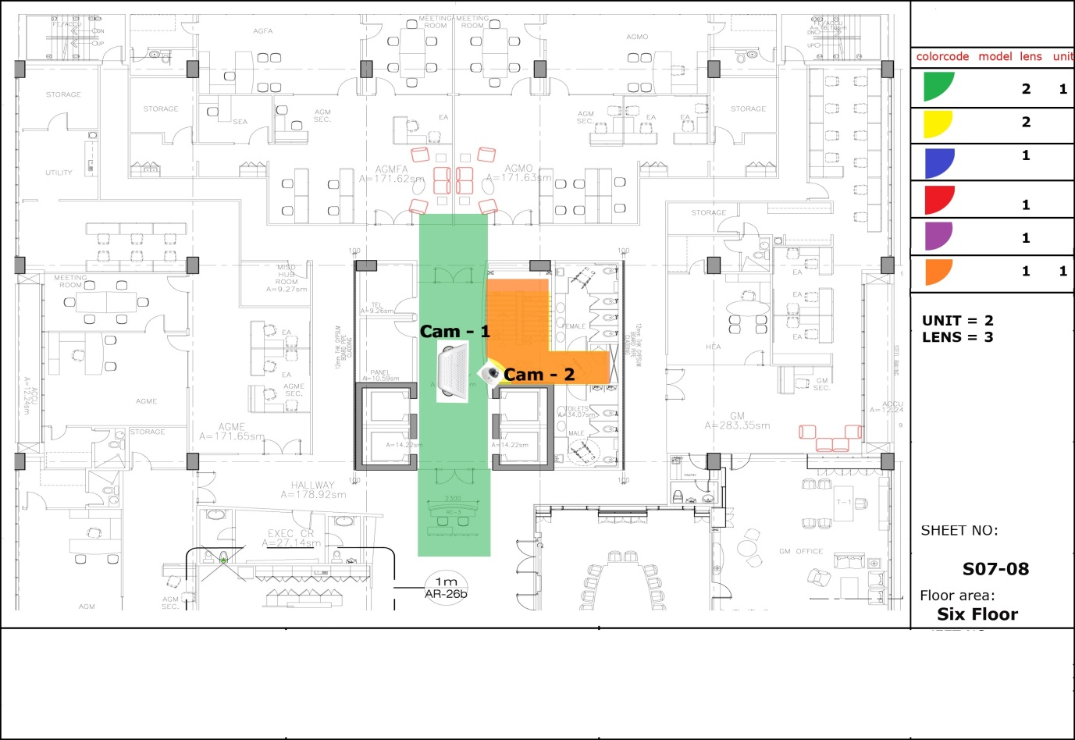

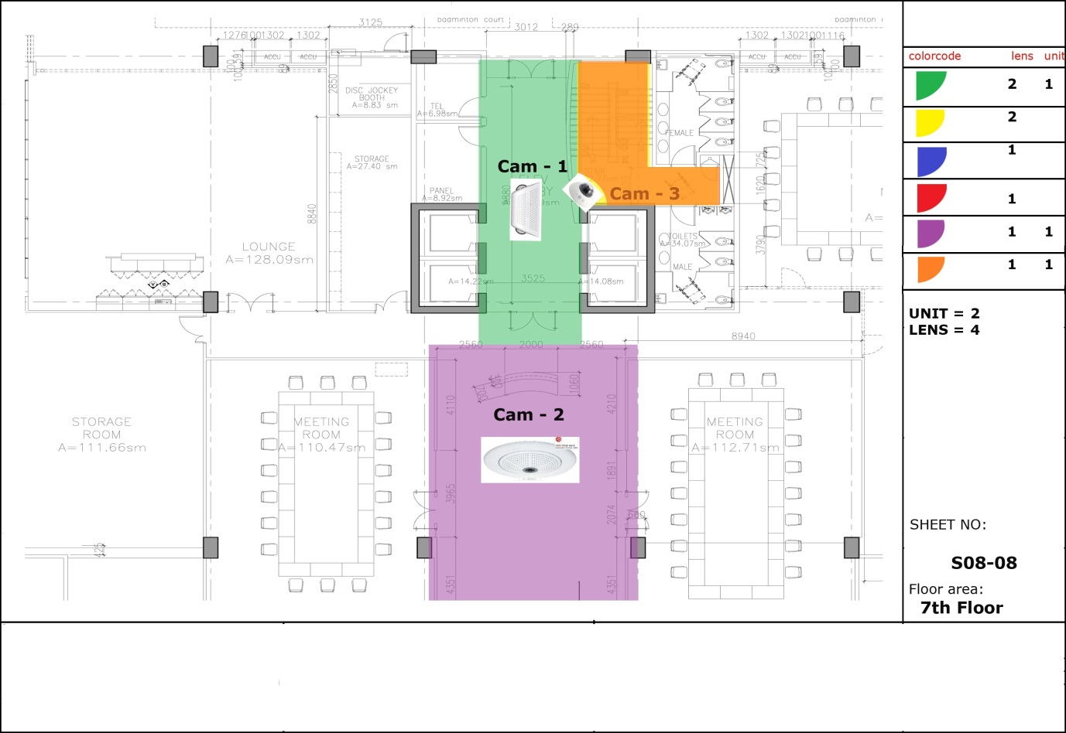

Annex “B”

OTHER SPECIFICATIONS

CAMERAS (29 sets with 45 views)

Description | Unit
Dual Lens Hallway | 10 sets
Indoor Dome | 8 sets
Outdoor Dual Dome | 6 sets
Outdoor | 3 sets
Hemispheric Dome | 1 set
360 degree Hemispheric Dome | 1 set
POE SWITCH
Description | Unit
Fully Managed Layer 2 POE Switch | 2 sets
SFP mini GBIC Module | 2 sets
CABLES
6-Core Outdoor-type MM Fiber Optic | 130 Lm
UTP Cat 6, 4-pairs | 6 rolls
SERVER/NVR
Manufacturer’s Standard
STORAGE DEVICE
Enterprise Hard Disk capable for 24/7 operation (computed in 30 days for 49 camera views)
WORK STATION
- Intel Core i7 or equivalent workstation
- Three (3) sets of at least 55” Monitors

