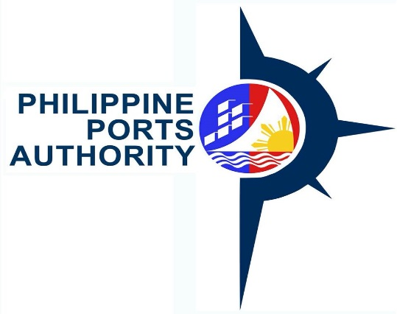

REQUEST FOR QUOTATION
(SMALL VALUE PROCUREMENT)
The Philippine Ports Authority, PMO-NOBBB, through its Bids and Awards Committee for
for Procurement of Goods will undertake an alternative method of procurement through
Shopping for the Supply, Delivery and Installation of Air-Conditioning Units, in accordance
with Section 52.1 (b) of the Revised Implementing Rules and Regulation of RA 9184.
Name of Project |  |  |  |  | : Supply, Delivery, and Installation
 |  |  |  |  | of Air-conditioning Units, as follows:
Item |  | Item/Description |  |  | Qty. | Units | ApprovedBudget
No. |  |  |  |  |  |  | for the Contract
1. |  | Air-Conditioning Units |  |  | 6 | Units | P 450,000.00
 |  | (2 HP, Split Type)
2. |  | Air-Conditioning Units |  |  | 10 | Units | P 300,000.00
 |  | (Window Type, 1HP)
 |  |  |  |  | TOTAL |  | P 750,000.00
Approved Budget for the Contract (ABC) |  |  |  |  | : P 750,000.00
Deadline of Submission |  |  |  |  | : November 26, 2018, 10:00AM
Please quote your best quotation in line with the attached specifications. Suppliers are
required to submit their valid and current Mayor's Permit, PhilGeps Registration Number,
Income/Business Tax Return and Omnibus Sworn Statement.
Quotations may be submitted personally to the BAC Secretariat, PPA Bldg., Banago Port,
Brgy. Banago, Bacolod City or email at monalizavillaran@ppa.com.ph.
For further information, please refer to:
 | MS. MONA LIZA G. VILLARAN
 | BAC Secretariat
 | Philippine Ports Authority, PMO-NOBBB
 | Banago Port, Brgy. Banago, Bacolod City
 | Telephone/Fax No. (034) 441-3124 / 441-1225
Very Truly Yours,
 | (Signed)
ARLYN A. CARAIG
Chairperson, Bids and Awards Committee
PPA & PhilGEPS Website: November 16, 2018 - November 26, 2018
PPAs Conspicuous Places: November 16, 2018 - November 26, 2018

