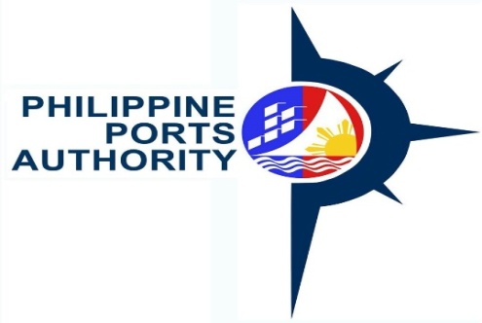

REQUEST FOR QUOTATION
(Shopping Sec. 52.1b)

The Philippine Ports Authority, PMO-NBB, through its Bids and Awards Committee for the Procurement of Goods and Consulting Services will undertake an alternative method of procurement through Shopping for the Supply and Delivery of Janitorial Supplies for 3rd Quarter CY 2020, in accordance with Section 52.1 (b) of the Revised Implementing Rules and Regulation of RA 9184.

Name of Project : Janitorial Supplies for 3rd Quarter CY 2020

Approved Budget for the Contract : Php 95,000.00

Deadline for Submission of Quotations : November 23, 2020, 12:00 Noon

Please quote your best quotation in line with the attached specifications. Suppliers are required to submit their valid and current Mayor’s Permit, PhilGeps Registration Number, Income/Business Tax Return and Omnibus Sworn Statement.

Quotation may be submitted to the BAC Secretariat, PPA Building, Banago Port, Brgy. Banago, Bacolod City or email at zbturtogo@ppa.com.ph

For further information, please refer to:

BAC Secretariat, Philippine Ports Authority, PMO-NBB
Banago Port, Brgy.Banago, Bacolod City
Telephone/Fax No. (034) 441-3124 / 441-1606

Very Truly Yours,

(Signed)
ARLYN A. CARAIG
Chairperson, Bids and Awards Committee
EP / PGCS

TECHNICAL PROPOSAL FORM

Item# | Qty. | Unit | Items & Specifications | Unit Cost | T O T A L
1 | 50 | pack | Detergent Powder, 500 grams/pack
2 | 30 | pack | Garbage Bag, small for garbage can, 100pcs./pack
3 | 30 | pack | Garbage Bag, XL size, 100pcs./pack
4 | 30 | gallon | Bleach
5 | 40 | bot | Air Freshener, Spray, 320g/bot
6 | 24 | pc. | Soft Broom, Heavy Duty
7 | 50 | bot | Insect Spray, big
8 | 50 | bot. | Disinfectant Spray, 500ml
9 | 20 | gallon | Alcohol, 70% Isopropyl
10 | 20 | gallon | Liquid Hand Soap, (Assorted Scent)
 |  |  | Janitorial Supplies for 3rd Quarter CY 2020

