IT EQUIPMENT SERVICE REQUEST FORM
Information and Communication Technology Department
Declaration and Data Privacy Consent: The information I have given is true, correct, and complete. By submitting this form, I authorize the Philippine Ports Authority to collect, use, process and retain my personal data in accordance with the PPA’s Privacy Statement and for purposes specified in this form.

ORSD FORM | Ref No. | SERVICE REQUEST
 |  | (To be Accomplished by Requesting Party)
RC |  | Name of Employee: (Full name, First Name, Middle Name) |  |  | Date/Time Reported
Detect/Problem
Name: |  |  | User Signature
ORSD FORM 002 | Ref No. | SERVICE SLIP
 |  | (To be Accomplished by ICTD Technical Personnel)
Diagnostics |  |  | Action Taken
Parts Replaced
Date Received |  | Time Received |  | User Signature
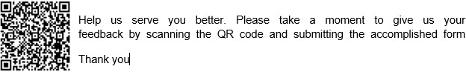
GENERAL INSTRUCTIONS:
- Indicate the Responsibility Center.
- Indicate the Name of Employee
- Indicate the Date and time reported.
- Fill in the Detect/Problem.
- Indicate name and affix signature of the person who requested.

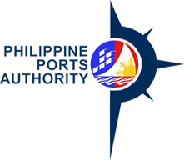 |  |  | PPA HEAD OFFICE |  |  | Doc. Ref. Code: |  | PM:APC:___:CFB:FM:01
 |  |  | RC: _________________________ |  |  | Revision No.: |  | 01
 |  |  |  |  |  | Date of Effectivity: |  | October 01, 2021
 | Thank you for giving us the opportunity to better serve you. We want to improve our service, please help us by answering this short survey.
 | (Maraming salamat sa pagkakataong kayo ay aming mapaglingkuran. Nais naming pagbutihin pa ang aming serbisyo, maaari po lamang pakisagot ang maiksing "survey" na ito.)
 |  |  |  |  |  | Yes |  |  | No
 |  |  |  |  |  | (Oo naman!) |  |  | (Hindi)
 |  |  |  |  | Please mark appropriate boxes with "√".
 |  |  |  |  |  | (Markahan ang mga boxes ng inyong sagot)
 | 1. CUSTOMER EXPERIENCE
 | A. Efficiency (Kaalaman at bilis ng serbisyo)
 | B. Courtesy (Magalang at madaling pakitunguhan)
 | 2. DID WE SERVE YOU WELL? (COMMENTS/SUGGESTIONS)
 | Naging maayos ba ang aming serbisyo? (Komento/Suhestiyon):
 | NAME & SIGNATURE: _____________________ |  |  |  | COMPANY: _______________
 | CONTACT NO. (required) :__________________  ___________________ |  |  |  | DATE/TIME:_______________
 | DECLARATION AND DATA PRIVACY CONSENT:
 | The information I have given is true, correct, and complete. I authorize the Philippine Ports Authority to collect, use,
 | process, and retain my personal data in accordance with the Philippines Ports Authority's Privacy Statement and for
 | purposes of collecting Customer Satisfaction Feedback.
 |  |  |  |  |  |  | I agree
 | Maaring ihulog sa itinakdang "SUGGESTION BOX" ang kumpletong "survey" na nasa "Security/Reception Desk" na matatagpuan sa PMO Building. MARAMING SALAMAT PO!

